Lab 1

Name of Lab
Student Name
Date
ECEN 250

Objectives
The objectives go here…

Preliminary
Preliminary stuff goes here…

Procedures
Equipment and supplies
- Include equipment here
Procedure
Step by step instructions go here. Include tables and graphs (see Table 1 and Figure 1). Make reference to them in your procedures. Next I measured the rise time, fall time, and percent overshoot (see Table 1).

Table 1: Name of Data
 | Calculated | Measured
Rise Time | 2.0 sec | 2.4 sec
Fall Time | 1.5 sec | 1.6 sec
Percent Overshoot | 10.0 % | 8.2%

Include more steps… I found the steady state error to be 1 (see Figure 1).

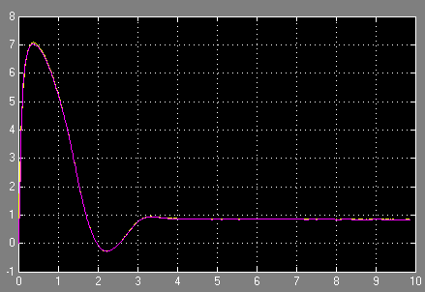
Figure 1: Steady State Error

Conclusion
Conclusion goes here and is more than a few lines…

Paste a copy of lab verification here…

